RESUME
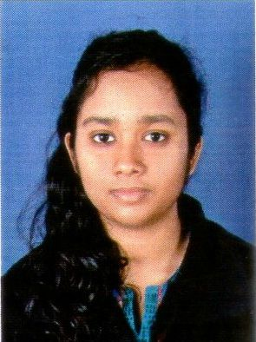
-ent Passrt size photograph With signature on it

1. Name (In Block letter): ISHANI MITRA
2. Father’s Name : DIPANKAR MITRA
3. Date of Birth : 19/03/1991 4 . Age as on (16.06.2016): 25 Years 2 Month(s) 89 Day(s)
5. Sex: Male/Female 6. Marital Status: SINGLE
7. Corresponding Address (BLOCK LETTER): 3-GREENLAND,KOLKATA,West Bengal PIN 700099.
8. Mobile No 9830318419 E-mail: ishani415@yahoo.co.in
9. Caste (SC/ST/OBC/PH etc.): GENERAL
10. Qualification:
Examination Passed | Year of Passing | Board/University | % of marks obtained | Subjects taken
ICSE | 2007 | CISCE | 88.14 | PHYSICS,CHEMISTRY,MATHS,BIOLOGY,COMPUTER APPLICATIONS,HISTORY AND CIVICS,GEOGRAPHY,ENGLISH,BENGALI,EVE.
ISC | 2009 | CISCE | 82.57 | PHYSICS,CHEMISTRY,MATHS,  COMPUTER SCIENCE,ENGLISH,BENGALI,EVE.
BSc (PHYSICS) | 2013 | CALCUTTA UNIVERSITY | 52.8 | PHYSICS,CHEMISTRY,MATHS.
MSc (ELECTRONIC SCIENCE) | 2015 | CALCUTTA UNIVERSITY | 69.5 | ELECTRONIC SCIENCE

11.Present Occupation:
(1)PHYSICS LECTURER AT SAMMILANI MAHAVIDYALAYA( AFFILIATED TO CALCUTTA UNIVERSITY)
(2) PHD RESEARCH SCHOLAR AT JADAVPUR UNIVERSITY.
12.Teaching Experience: 3.5 years

13.Extra curricular activities: LEARNT CLASSICAL MUSIC FOR 5YEARS,PART OF THE SCHOOL QUIZ TEAM,PAINTING,READING.

